**SOMAIYA**



**V I D Y A V I H A R**

**K J Somaiya Institute of Technology**

**An Autonomous Institute Permanently Affiliated to the University of Mumbai DEPARTMENT OF INFORMATION TECHNOLOGY Course: Data Structures Lab( ITL405)**

**B.Tech. (Information Technology) – Semester III**

**Academic Year: 2024-25(Odd Semester)**

**EXPERIMENT 5**

***Aim:*** To implement and demonstrate the functionalities of a Singly Linked List, including insertion, deletion, searching, and displaying elements, to understand the basic operations and applications of linked lists in computer science***.***

***Lab Objective:***

1. To use the basic principles of programming as applied to complex data structures.

2. To learn the principles of Linked List and its various operations.

**CODE:-**

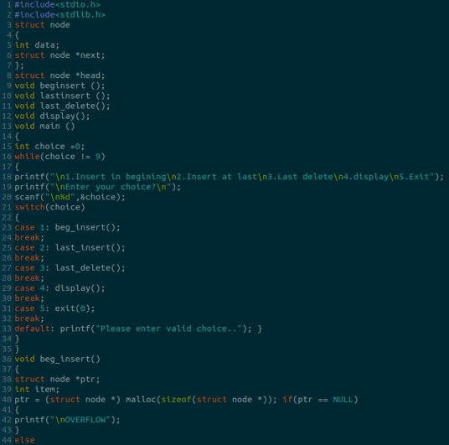

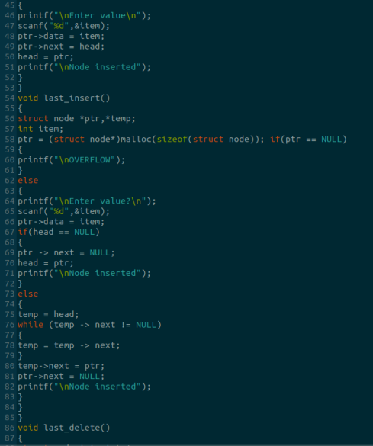

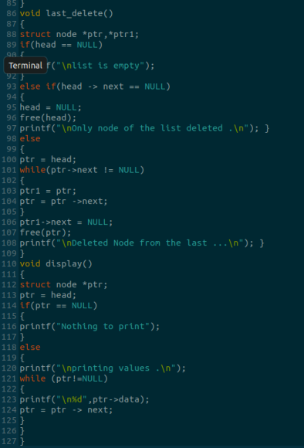

OUTPUT:

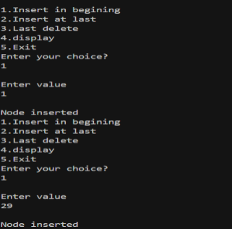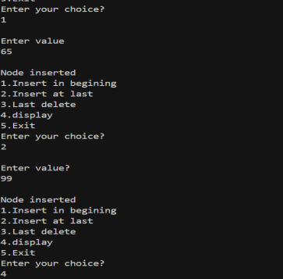

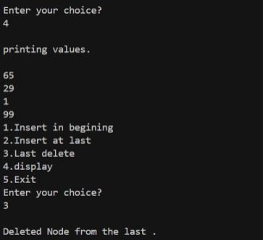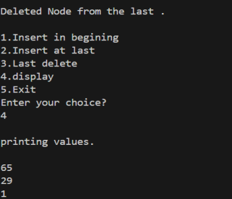

**Submission Details**

Name of Student:Faizan Dodiya

Roll No.: 24

Div: A

Date of Performance: 30/08/2024